Install Apache and Run Apache on Port Number 82
Here is the solution.

Step-by-Step Instructions
1. Start your Ubuntu VM.
2. Open a Terminal (Ctrl + Alt + T).
3. Update the package list:
sudo apt update
4. Install Apache Web Server:
sudo apt install apache2 –y

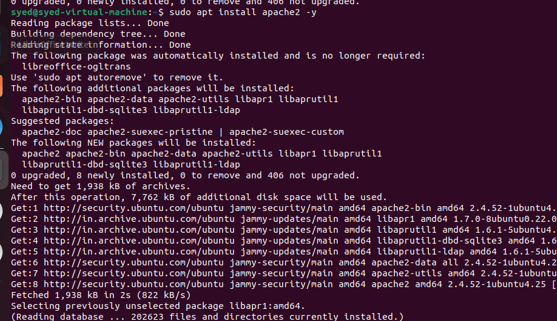
5. Configure Apache to use port 82.
Open the ports configuration file:
sudo nano /etc/apache2/ports.conf
Find "Listen 80" and change it to "Listen 82".
Save with Ctrl + O, press Enter, and exit with Ctrl + X.
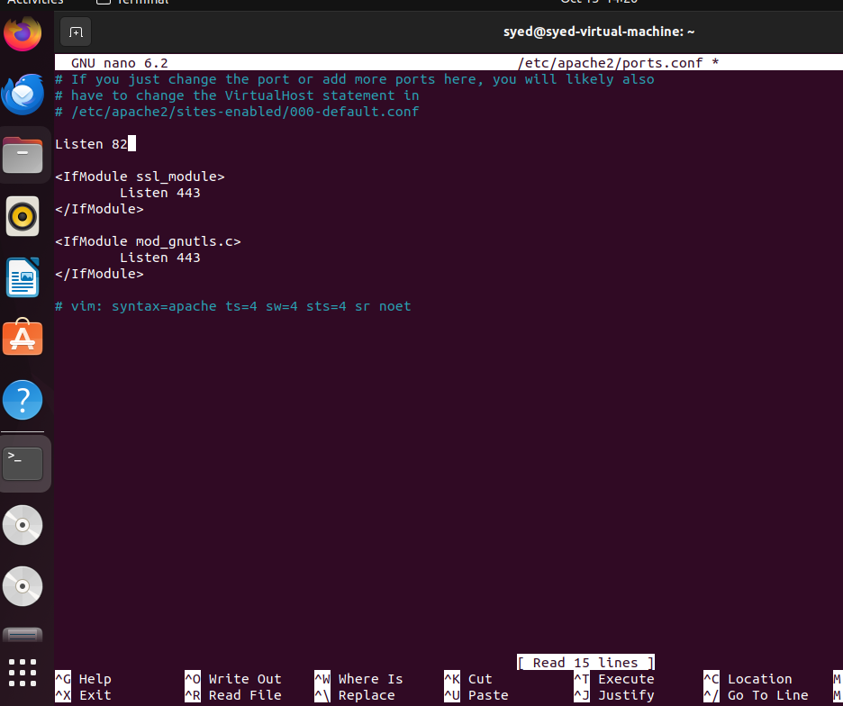
6. Update the Apache virtual host configuration.
Open the default configuration file:
sudo nano /etc/apache2/sites-available/000-default.conf
Find "<VirtualHost *:80>" and change it to "<VirtualHost *:82>".
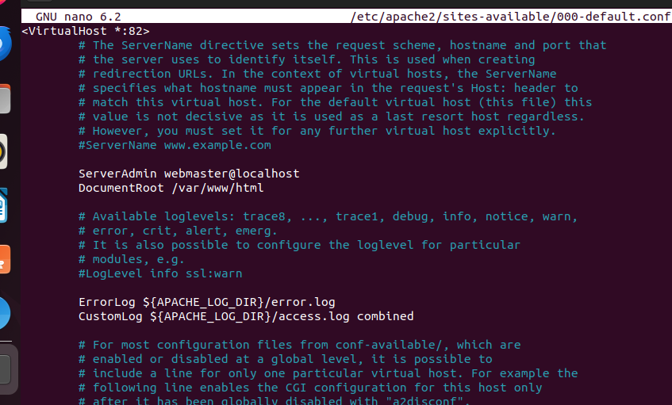
Save with Ctrl + O, press Enter, and exit with Ctrl + X.
7. Allow port 82 through UFW:
sudo ufw allow 82/tcp
sudo ufw status
8. Test the Apache configuration:
sudo apache2ctl configtest
Expected output: Syntax OK
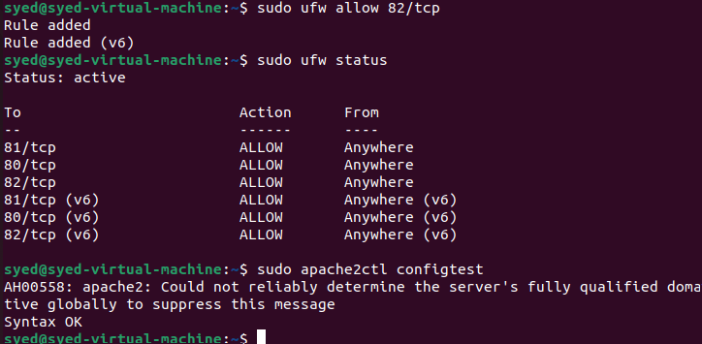
9. Restart Apache:
sudo systemctl restart apache2
sudo systemctl status apache2 --no-pager
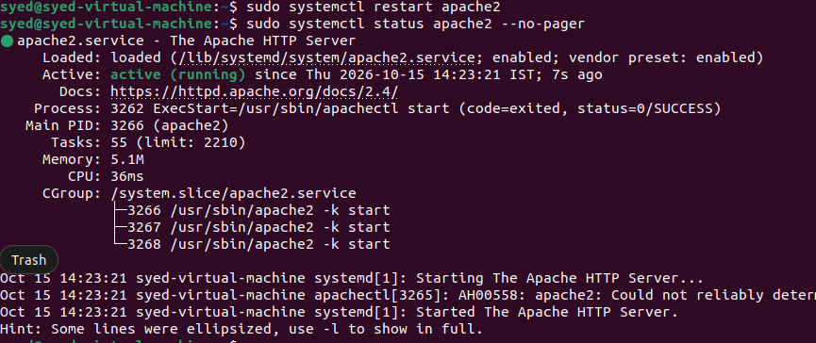

10. Verify Apache is listening on port 82:
sudo ss -lntp | grep ':82'
11. Test Apache in the terminal:
curl -I http://localhost:82
Expected response includes: HTTP/1.1 200 OK
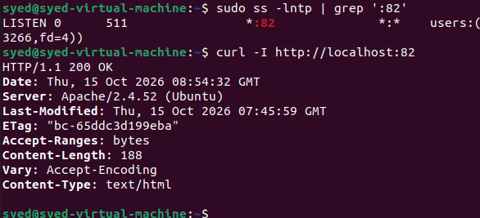
12. Open Apache in the browser.
Open Firefox in Ubuntu and enter:
http:// 192.168.2.128:82
The Apache2 Ubuntu Default Page should appear.
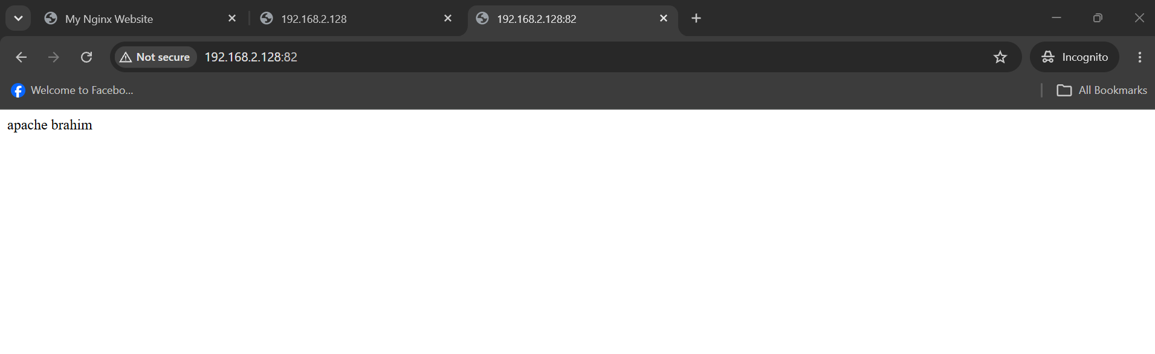

Important Note
If Nginx is already running on port 81, it can keep using that port while Apache uses port 82. Both web servers can run simultaneously on different ports.
If Apache fails to restart, check the error with:host
sudo journalctl -u apache2 --no-pager -n 30
